Symposium Instructions

1. Registration and Payment
(1) The deadline for registration and payment is October 1, 2026. Your submitted personal information will be kept strictly confidential and used solely for conference preparation and services. Cancellation and refund requests will be accepted only before November 1, 2026. We appreciate your understanding.
(2) To ensure successful registration, please complete your payment after receiving our official confirmation email soon.
(3) After payment is completed, you will receive a confirmation email titled "Payment Accepted" within two weeks, which will serve as your payment receipt.

Account Name: ShanghaiXingheEnterpriseConsultingManagementCo., Ltd.
Account Number: 121937257410101
Head Office Name of China Merchants Bank: China Merchants Bank, Head Office, Shenzhen,
P.R. China
HeadOffice address: China Merchants Bank Tower No.7088, Shennan Boulevard, Shenzhen,
China
Swift Code: CMBCCNBS (If an 11-digit code is required, please contact us to provide it.)
Remarks: Name - Sasanqua - Registration Fee

2.Accommodation
A) SSAW Boutique Hotel Shanghai South Xuhui上海徐汇日月光同文君亭酒店
Hotel Website：https://hotels.ctrip.com/hotels/1618790.html
Address: 17 Guilin Road, Xuhui District, Shanghai
Rate: Negotiated rate: RMB 420 per night
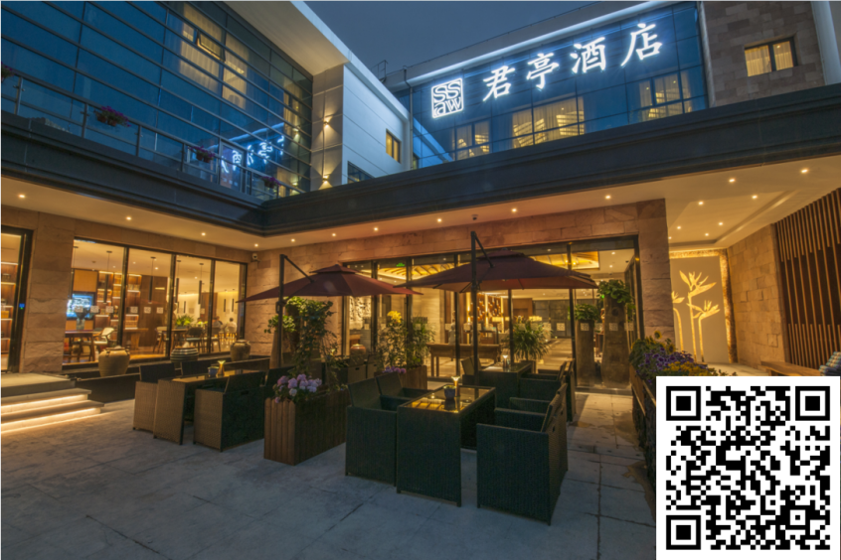
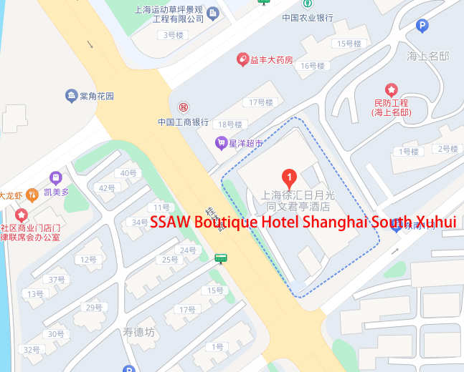

B) Holiday Inn Shanghai Huaxia上海华夏假日酒店
Hotel Website：https://www.ihg.com.cn/holidayinn/hotels/cn/zh/shanghai/shacr/hoteldetail
Address: 38-1 Caobao Road, Xuhui District, Shanghai
Rate: Negotiated rate: RMB 500 per night
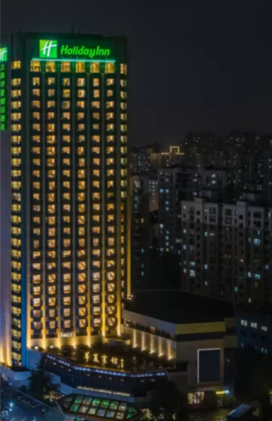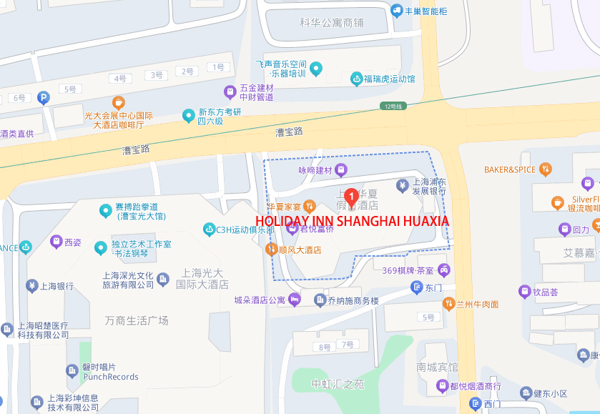
3. Disclaimer
This disclaimer applies to the conference and the post-conference study tour, collectively referred to as the ‘International Sasanqua Symposium’.
(1) Registered participants travel and attend the activities of the ‘International Sasanqua Symposium’
at their own risk.
(2) Participants of the ‘International Sasanqua Symposium’ shall arrange and pay for their personal travel and medical insurance and hereby waive any liability of the organizers.
4. Invitation Letter
If required, an invitation letter will be provided via email.
5. Transportation Guidelines
Complimentary airport transfers are available from 6:00 AM to 10:00 PM on December 3. Outside of this period, please arrange your own transportation to the hotel.
For any transportation-related inquiries or if you cannot reach the assigned driver, please contact:
Zhang Jiahong
Mobile: +86 131 6251 5256
For international guests attending the "International Sasanqua Symposium" here is the complete guide for traveling from all major Shanghai airports and train stations to your conference hotel. This guide prioritizes clarity, convenience, and cost-effectiveness for foreign travelers.
Hotel: SSAW Boutique Hotel Shanghai South Xuhui (上海徐汇日月光同文君亭酒店)
Address: No. 17, Guilin Road, Xuhui District, Shanghai (上海市徐汇区桂林路17号)
Nearest Metro Station: Line 1/15 - Shanghai South Railway Station（上海南站）, Exit 6 (approx. 15-minute walk)

A. Recommended Options at a Glance
Your Arrival Point | Top Recommendation (Most Convenient) | Budget Recommendation | Estimated Travel Time
Pudong Airport (PVG)（浦东机场） | Didi / Taxi (Door-to-door) | Maglev + Metro | 60-90 mins
Hongqiao Airport (SHA) （虹桥机场）/ Hongqiao Railway（虹桥火车站） | Didi / Taxi (Short ride) | Metro (Line 10 → Line 15) | 30-50 mins
Shanghai Railway Station（上海站） | Didi / Taxi | Metro (Line 1) | 35-45 mins
Shanghai South Railway Station（上海南站） | Didi / Taxi (Very short ride) | Walk | 10-20 mins

B. Detailed Strategies & Cost Breakdown

1. From Shanghai Pudong International Airport (PVG)上海浦东国际机场
(Farthest from the hotel, multiple options available)
Method | Step-by-Step Instructions | Est. Cost (RMB) | Est. Time | Pros & Cons
Taxi / Ride-Hailing (Didi) | Follow signs to the official Taxi Stand. Show the driver the hotel's Chinese address: 徐汇区桂林路17号. | 180 - 220 | 50-70 mins | Pros: Most convenient, door-to-door.  Cons: Highest cost, traffic-dependent.
 | For Didi (China's Uber), use the international app. Set pickup at the designated "Ride-Hailing" area. | 160 - 200 | 50-70 mins | Pros: Fixed price estimate, easy payment via app.  Cons: Requires app setup and internet.
Maglev + Metro | - Take the Metro Airport Link to Jinghong Station （景洪站）(30 mins).  2. Transfer to Metro Line 15 to Shanghai South Railway Station（上海南站）, Exit 6.(15 mins).  3.Then take a short taxi ride (or walk) to the hotel. | 17 + 3 = 21 | 70-80 mins | Pros: Cost-effective  Cons: Multiple transfers with luggage.
Airport Bus + Taxi | 1.Take Airport Bus Line 7 to Shanghai South Railway Station（上海南站）.  2.Then take a short taxi ride (or walk) to the hotel. | 20 + 15 = 35 | 80-110 mins | Pros: Cost-effective, direct bus to south area.  Cons: Longer total time, two separate rides.

2. From Shanghai Hongqiao Airport (SHA) / Hongqiao Railway Station上海虹桥机场/上海虹桥火车站
(Closest air hub, very convenient)
Method | Step-by-Step Instructions | Est. Cost (RMB) | Est. Time | Pros & Cons
Taxi / Ride-Hailing (Didi) | Follow signs to the Taxi Stand. The ride is straightforward on the elevated expressway. | 50 - 70 | 25-40 mins | Pros: Fast and direct.  Cons: Possible queue at the taxi stand.
 | Use Didi App for pickup at designated areas in T1 or T2. | 45 - 65 | 25-40 mins | Pros: Often quicker than taxi queue.
Metro (Most Economical) | - At Hongqiao T2 or Railway Station, take Metro Line 2(towards Terminal 1 and 2 of Pudong 浦东1号2号航站楼方向).  2. Get off at Loushanguan Road Station（娄山关路站）and transfer to Line 15 (towards Zizhu Park 紫竹高新区方向). Alight at Shanghai South Railway Station（上海南站）, Exit 6.  3.Then take a short taxi ride (or walk) to the hotel. | 5 | 40-55 mins | Pros: Extremely cheap, reliable, avoids traffic.  Cons: Requires navigating transfers with luggage.

3. From Shanghai Railway Station上海火车站
(Main station in downtown)
Method | Step-by-Step Instructions | Est. Cost (RMB) | Est. Time | Pros & Cons
Taxi / Ride-Hailing (Didi) | Taxi stand is located outside the main exits. | 35 - 50 | 25-35 mins | Pros: Hassle-free with bags.
Metro | - Take Metro Line 1 (towards Xinzhuang 莘庄方向) .  - Get off at Shanghai South Station（上海南站）.  - Then take a short taxi ride (or walk) to the hotel. | 4 | 35-45 mins | Pros: Cheap and efficient.

4. From Shanghai South Railway Station上海南站
(Closest railway station to the hotel)
Method | Step-by-Step Instructions | Est. Cost (RMB) | Est. Time | Pros & Cons
Taxi / Ride-Hailing (Didi) | A very short and cheap ride. | 15 - 25 | 10-15 mins | Pros: Ideal if you have luggage.
Walk | It is a 15-minute walk. | free | 10-20 mins | Pros: The walk is manageable with light luggage.

C. Essential Tips for Guests
Prepare the Address: Save this in your phone notes to show drivers:
Chinese: 徐汇区桂林路17号，上海徐汇日月光同文君亭酒店
English: SSAW Boutique Hotel Shanghai South Xuhui, No. 17 Guilin Road, Xuhui District.
Payment Methods:
Taxis: Have RMB cash ready. Most taxis now also accept Alipay or WeChat Pay (requires a Chinese bank account), and some support international credit cards via contactless payment.
Didi: The best option. Use the international version of the app, link your international credit card, and pay seamlessly within the app.
Connectivity: Purchase a local SIM card or enable international roaming immediately upon arrival for using maps and ride-hailing apps.
Avoid Solicitors: Politely decline offers from unauthorized drivers inside the terminals. Always use official taxi stands or booked cars.

D. Summary Cost Table (Single Trip in RMB)
Departure Point | Taxi | Didi (Ride-Hail) | Public Transport (Metro/Bus)
Pudong (PVG) Airport（浦东机场） | 180 - 220 | 160 - 200 | ~35 - 56
Hongqiao (SHA) Airport（虹桥机场） | 50 - 70 | 45 - 65 | 5
Hongqiao Railway（虹桥火车站） | 50 - 70 | 45 - 65 | 5
Shanghai Railway Station（上海站） | 35 - 50 | 30 - 45 | 4
Shanghai South Railway（上海南站） | 15 - 25 | 15 - 25 | 3 (or walk)
We wish you a pleasant journey to Shanghai! For any urgent assistance upon arrival, please contact the conference organizer.

