Inaugural Meeting of the ICS Committee for Historic Camellia Conservation, Nantes 26 March 2018

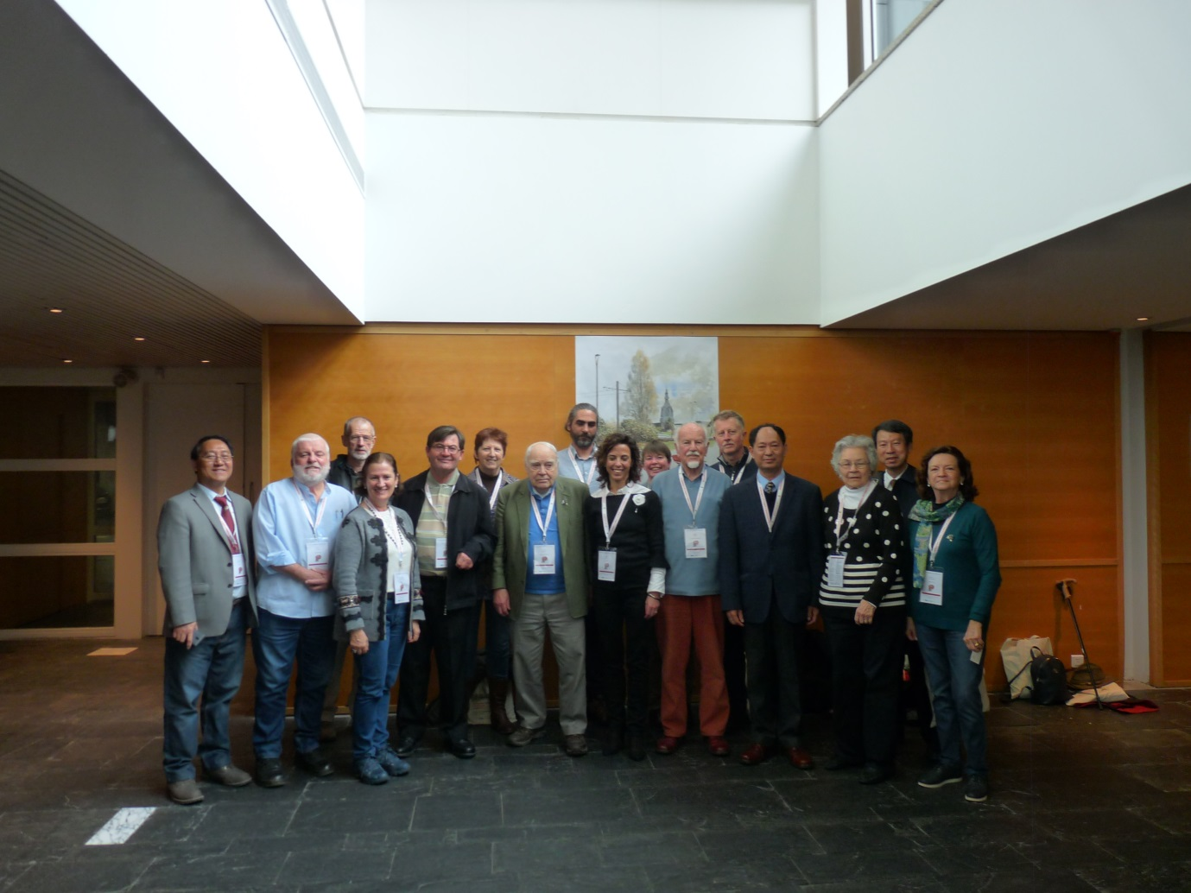
Core of the ICS Committee photographed in Nantes, France (after the first meeting held on 26 March 2018): Left to right - Dr Li Jiyuan (China), Anthony Curry (South East Asia representative), Kevin Bowden (observer, Australia), Dr Carmen Salinero (Spain), Dr Stephen Utick (Chair), Frieda Delvaux (Benelux), Herb Short (UK), Pascal Vieu (observer, France), Dr Pilar Vela (observer, Spain), Geraldine King (observer, UK), John Price (observer, UK), Dr Andrea Corneo (Italy), Prof. Guan Kaiyun (ICS President), Florence Crowder (North America), Prof. Takayuki Tanaka (Japan) and Joana Guedes (observer, Portugal).

Over 40 members and observers crowded into the administration room provided by the City of Nantes on the afternoon of 26 March 2018 for the inaugural meeting of this new Committee. Just to remind of the Committee’s objectives: these are:
• To inform the ICS and its membership about the historical and cultural context of such cultivars, including newly uncovered ethnobotanical detail;
• To advise the ICS of strategies that would better encourage conservation and preservation of historic cultivars globally;
• To bring together ICS representatives from various global regions with an active interest or expertise in conservation matters;
• To identify individual cultivars from different global regions which could be promoted and supported for preservation, particularly through exchanges of scions or cuttings; and
• To receive feedback and ideas from ICS members (including at congresses).
All of the regions or countries including China, Japan, South East Asia, North America (mostly USA), the UK, Spain, Benelux, Italy, Portugal and Oceania, had their representatives and accompanying observers present. A significant number of Chinese representatives were also present.
Following the opening formalities, Committee representatives gave reports on significant historic cultivars from their respective countries and regions. Regrettably, the Committee was unable to thrash out strategies given the large number of regional reports to be covered over the time allotted for the meeting. As later reported back to the ICS Directors’ meeting, I noted that it was important that all camellia regions accept the Committee’s new operations, and to respect the need to have input across different cultures particularly given how these have impacted of the story of historic camellias. As Chair, I am now confident that we can move forward though.
It was clear that any strategies for conservation of historic trees would be different from those directed at conservation of historic cultivars. There was also acceptance that global circulation of historic cultivars would need to adapt to the growing quarantine restrictions and we look forward to any update from the American Camellia Society on streamlining processes. There was some discussion about continuing exchanges for Japanese HIGO collections. As Chair, I also noted the historic significance of the Japanese wabisuke camellias.
Conservation of Ancient or Historic Camellia Trees
During the Nantes meeting, the Chinese delegation flagged developing a strategy for conservation of historic camellia trees. Some ICS members may recall that ancient camellia trees was a topic for discussion at a conference in Pallanza Italy during 2013 under the previous Working Group, which this new formalised Committee now replaces.
While developing a global strategy and protocol for conserving ancient camellia trees is obviously a priority for China, it would also be of considerable strategic value to all camellia growing countries where there is no real protection for such trees other than perhaps the occasional heritage listing. Of interest is the fact that the Chinese already distinguish between native forest trees (some of these can reach 500 years or more in age) and ornamental specimens (which themselves can live for hundreds of years and in which we of course would have an interest). It is also worthwhile noting the outstanding work that the Spanish ICS representatives Dr Carmen Salinero and Dr Pilar Vela have undertaken in measurements of ancient trees in Spanish gardens throughout Galicia. More broadly and in addition to the centuries-old trees in Japan and Vietnam, many surviving camellia trees in Europe, Britain, the United States, Australia and New Zealand are reaching 150 years old or more, reflecting the nineteenth century love of camellias across the world.
Many thanks to the City of Nantes and conference administrator Magali Brunelli for helping us stage the meeting.
Next Meeting: Guangdong China, October 2019
The topic of conserving ancient camellia trees will be the subject of the next meeting of the Committee which is likely to be held in Guangdong Province China during mid October 2019. The key focus would be to develop a global protocol for conservation of such trees plus other promotional strategies. This would enable any recommendations to be brought to the ICS Directors’ meeting at the next ICS Congress scheduled for March 2020 in Goto Japan. Over the next nine months or so, I will be working with Prof Wang Zhonglang and Dr Xu Lin on the development of an agenda, and finalising a visit programme. With respect to that programme, I would like to express my sincerest thanks on behalf of the ICS to Apolui Camellia Tourism Valley near Conghua City for offering to host this meeting and to cover accommodation and Guangdong travel costs for delegates. This aspect too is subject to finalisation but I will keep Committee members informed of developments. Delegates would otherwise have to cover their return airfare costs plus expenses for any supplementary trips during our stay.
Those Committee representatives who are unable to attend are encouraged to send a proxy given the strategic importance of that meeting. There is scope for involvement by a select group of other ICS members with specialist expertise (particularly in camellia trees or cultural aspects); to anyone interested please contact me by end of March 2019 on sutick@grapevine.com.au with a brief resume.
.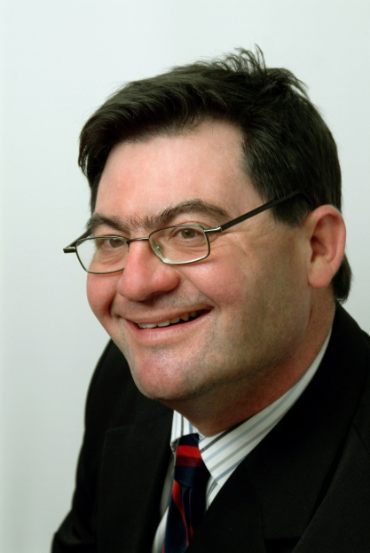
Left: Dr Stephen Utick. Committee Chair

